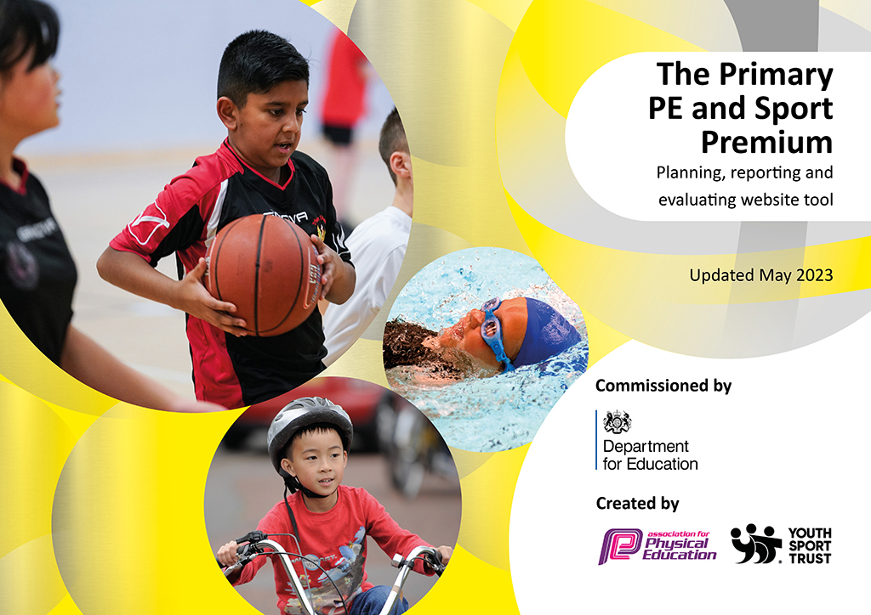
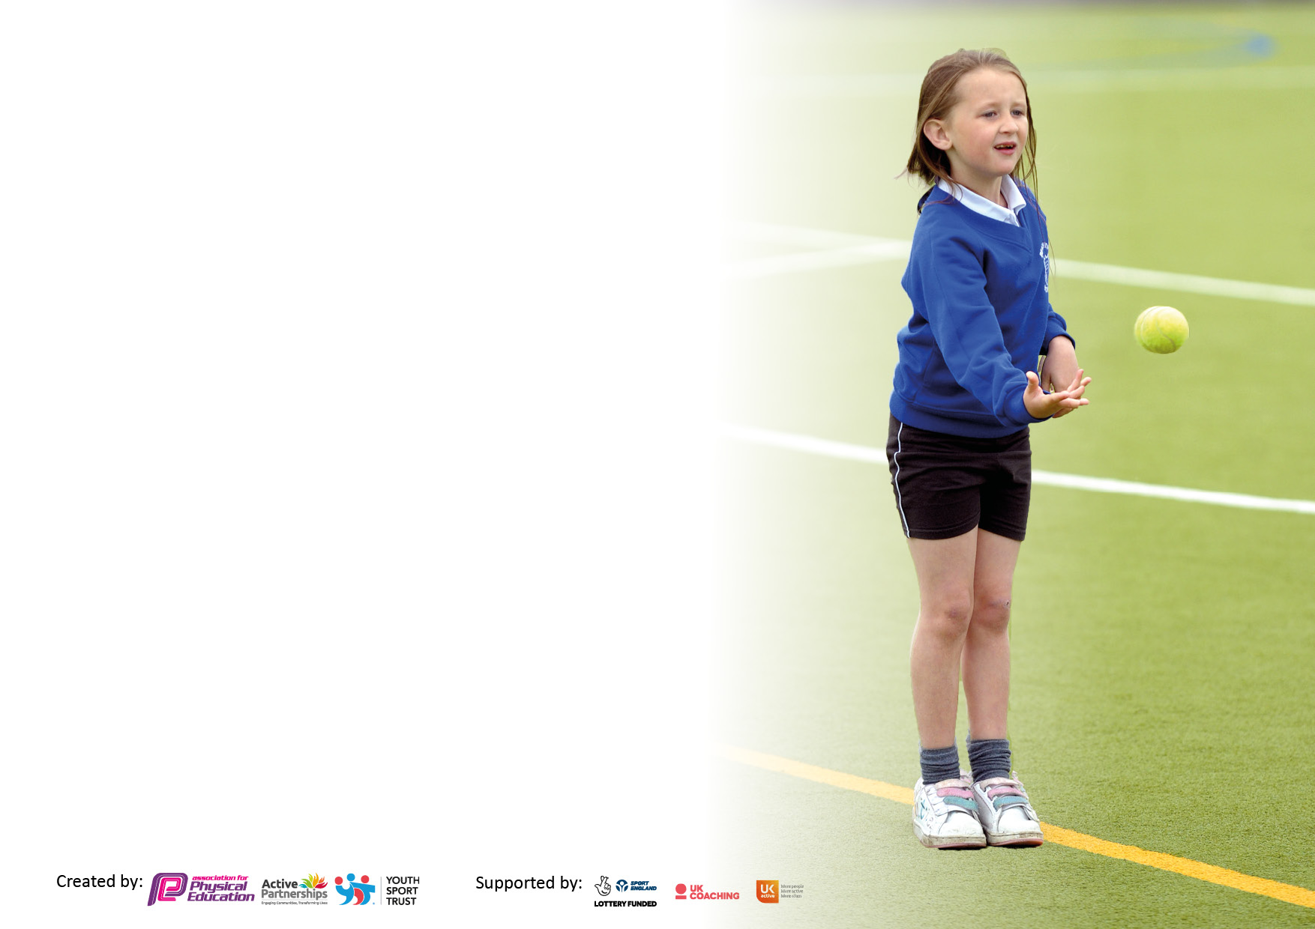

It is important that your grant is used effectively and based on school need. The Education Inspection Framework makes clear there will be a focus on ‘whether leaders and those responsible for governors all understand their respective roles and perform these in a way that enhances the effectiveness of the school’.

Under the Quality of Education judgement, Ofsted inspectors consider:
Intent - Curriculum design, coverage and appropriateness
Implementation - Curriculum delivery, teaching (pedagogy) and assessment
Impact - Attainment and progress

To assist schools with common transferable language, this template has been developed to utilise the same three headings which should make your plans easily transferable between working documents.

Schools must use the funding to make additional and sustainable improvements to the quality of Physical Education, School Sport and Physical Activity (PESSPA) they offer. This means that you should use the Primary PE and sport premium to:

- Develop or add to the PESSPA activities that your school already offers
- Build capacity and capability within the school to ensure that improvements made now will benefit pupils joining the school in future years
- The Primary PE and sport premium should not be used to fund capital spend projects; the school’s budget should fund these.

Please visit https://www.gov.uk/guidance/pe-and-sport-premium-for-primary-schools for the revised DfE guidance, including the 5 key indicators across which schools should demonstrate an improvement. This document will help you to review your provision and to report your spend. DfE encourages schools to use this template as an effective way of meeting the reporting requirements of the Primary PE and Sport Premium.

We recommend you start by reflecting on the impact of current provision and reviewing the previous spend.

Schools are required to publish details of how they spend this funding, including any underspend from 2021/2022, as well as on the impact it has on pupils’ PE and sport participation and attainment.

We recommend regularly updating the table and publishing it on your website throughout the year. This evidences your ongoing self-evaluation of how you are using the funding to secure maximum, sustainable impact. Final copy must be posted on your website by the end of the academic year and no later than the 31 July 2023.

Details with regard to funding
Please complete the table below.

Total amount allocated for 2022/23 | £16,930
Total amount of funding for 2022/23 to be reported on by 31st July 2023 | £ 16.930
Swimming Data
Please report on your Swimming Data below.

Meeting national curriculum requirements for swimming and water safety.  N.B. Complete this section as best you can. For example, you might have practised safe self-rescue techniques on dry land which you can then transfer to the pool when school swimming restarts.  Due to exceptional circumstances priority should be given to ensuring that pupils can perform safe self-rescue even if they do not fully meet the first two requirements of the NC programme of study | 16 Year 6 pupils in cohort 22/23
What percentage of your current Year 6 cohort swim competently, confidently and proficiently over a distance of at least 25 metres?  N.B. Even though your pupils may swim in another year, please report on their attainment on leaving primary school at the end of the summer term 2023.  Please see note above | 100%
What percentage of your current Year 6 cohort use a range of strokes effectively [for example, front crawl, backstroke and breaststroke]?  Please see note above | 100%
What percentage of your current Year 6 cohort perform safe self-rescue in different water-based situations? | 100%
Schools can choose to use the Primary PE and sport premium to provide additional provision for swimming, but this must be for activity over and above the national curriculum requirements. Have you used it in this way? | Yes/No

Action Plan and Budget Tracking
Capture your intended annual spend against the 5 key indicators. Clarify the success criteria and evidence of impact that you intend to measure to evaluate for pupils today and for the future.

Academic Year: 2023/24 | Total fund allocated: | Date Updated:
Key indicator 1: Increase confidence, knowledge and skills of all staff in teaching PE and sport |  |  |  | Percentage of total allocation:
 |  |  |  | 10%
Intent | Implementation |  | Impact | Sustainability and suggested next steps
Ensure all teaching staff have confidence to deliver high quality PE across the whole range of sports [no longer accessing any sport coach sessions so teacher led PE]. | Input from a PE specialist [own staff or within Unity]. Support teachers on a one-to-one basis in their own school with their own pupils.  Further develop the use of Chris Quigley PE Companion resources. | £500 | Staff are able to access planning and ideas to promote their P.E lessons | Further support new staff in planning
To enhance and improve current P.E provision | Hiring specialist P.E coaches (ICS) to model high quality sport sessions which teaching staff and support staff engage with to inform their own teaching | £600 x 2 = £1200 | Children are engaging positively in P.E lessons showing improved behaviour | 2 out of 3 teachers new for 2023/2024 therefore modelled sessions to continue across the year for a variety of sports.
Key indicator 2: The engagement of all pupils in regular physical activity – Chief Medical Officers’ guidelines recommend that  primary school pupils undertake at least 30 minutes of physical activity a day in school |  |  |  | Percentage of total allocation:
 |  |  |  | 37%
Intent | Implementation |  | Impact
To promote positive active playtimes | Young Leaders trained within the Autumn Term. Delivery 15 minutes of daily circuits on the playground.  Organise a family fun health day – colour run included (as part of Health and Wellbeing week) | £1000  £600 | Year 4/5 pupils trained through ICS  MSA playtime training undertaken | Further training for pupils in next year.  Monitoring of playtimes for reduction in incidents  Opportunities for indoor play provision
Target teaching to those in most need - those disengaged and those who lack physical control and coordination or with low levels of fitness | Teaching assistants to deliver focused interventions linked to positive engagement and activity including mornings and afternoons.  Teaching assistants to deliver Sensory circuits | TA hours per week  £2500  Sensory equipment £2000 | Sensory room set up which is accessed by pupils throughout the school day  Sensory corridor used to support children at specified times. | Sensory training for staff to support in identifying sensory needs in individuals.

Key indicator 3: The profile of PE and sport is raised across the school as a tool for whole school improvement |  |  |  | Percentage of total allocation:
 |  |  |  | 15%
Intent | Implementation |  | Impact
Your school focus should be clear on what you want the pupils to know and be able to do. What do they need to learn and to consolidate through practice: | Make sure your actions to achieve are linked to your intentions: | Funding allocated: | Evidence of impact:  What do pupils now know and what can they now do? What has  changed? | Sustainability and suggested next steps:
Raise profile of sports across the school community | ‘Health and Wellbeing’ Week – including a “Federation” sports day and other events across the week.  including hire of local venue, equipment, use of outside sport specialists. | £2500 | Children participated in a range of sporting events:  *colour run  *yoga  *fencing  *hockey  *KS2 athletics sports day. | Continue with health and well being week – introduce further different sports.
Key indicator 4: Broader experience of a range of sports and physical activities offered to all pupils |  |  |  | Percentage of total allocation:
 |  |  |  | 20%
Intent | Implementation |  | Impact
Your school focus should be clear on what you want the pupils to know and be able to do. What do they need to learn and to consolidate through practice: | Make sure your actions to achieve are linked to your intentions: | Funding allocated: | Evidence of impact:  What do pupils now know and what can they now do? What has  changed? | Sustainability and suggested next steps:
Teach children to be healthy and to think about their own health in regard to  - Fitness and exercise  - Healthy eating  - Healthy mind  Provide children with a range of sports and active learning opportunities | Target disadvantaged pupils by introducing children to a new sport or a wider range of sports through an extensive after school club programme.  Healthy lifestyle lessons as part of PSHE Curriculum.  Booster swimming sessions for Year 6 – Summer Term | £500  £440  £600 (including sessions and transport) | After school club provision – all children had the opportunity to attend a sports club. | Continue to provide sporting opportunities after school
To ensure P.E resources are fit for purpose | Equipment audit in line with long term planning - purchase of equipment  Release time for staff | £800 | P.E equipment purchased in line with curriculum plan | Continue to audit equipment in future academic years.
To support EYFS and KS1 in learning to ride a bike | Introduction of balancability | £900 | Pupils engaged in first sessions before the summer break. | Timetables slots for balancability – no further costs.

Key indicator 5: Increased participation in competitive sport |  |  |  | Percentage of total allocation:
 |  |  |  | 18%
Intent | Implementation |  | Impact
Your school focus should be clear on what you want the pupils to know and be able to do. What do they need to learn and to consolidate through practice: | Make sure your actions to achieve are linked to your intentions: | Funding allocated: | Evidence of impact:  What do pupils now know and what can they now do? What has  changed? | Sustainability and suggested next steps:
Children take part in competition with other schools | Competitions to be sought with local schools through Unity. | £995  £1000 transport | 40% pupils across year groups participated in competitions. | Continue to participate in competitions and review children involved/ participation
Ensure every child by the end of Year 6 has represented the school in a sporting activity. | Subject leader team to keep a track on who has attended which event and promote events to all children. | £900 | Children participated in a range of competitions including cross country, tennis, hockey, athletics. | Continue to participate in competitions and review children involved/ participation

Signed off by
Head Teacher: | Louise Arrowsmith
Date: | July 2023

